ELEC 3300 Project Summary Sheet
This is a ONE Page Summary Sheet, Content more than 1 page will be deleted.
All the fonts used in this Sheet should be in Times New Roman at 12 points

Group Number | 44
Project Title | Air Drum
Name of Student 1 | Ho Cheuk Lam
Name of Student 2 | Chan Lik Yeung
Name of Student 3 | Hartanto Kwee Jeffrey

Please attach ONE photo of your project below
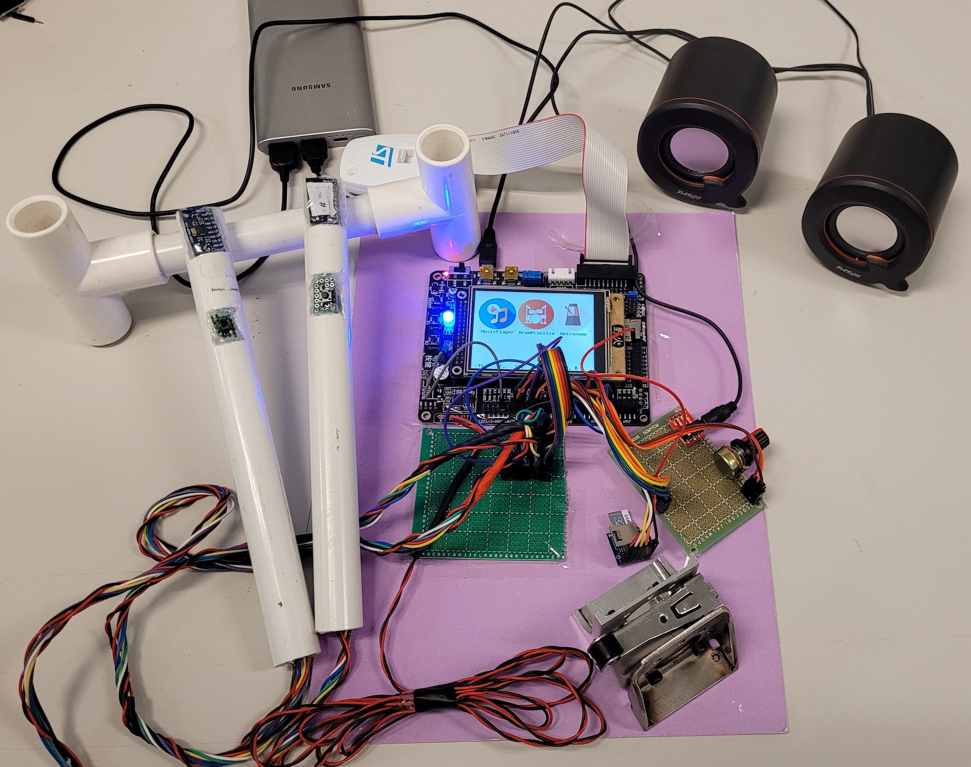

Please list the functions of your project in point form
- Drumsticks motion tracking. By moving the drumsticks in mid-air, the users could select one of the four drums individually (IMU by SPI)
- Drum hit detection with sound. When the user hits the drum, sound from the corresponding drum will be played (Positioning algorithm with IMU data)
- Mini drum pedal. Made with a limit switch, stepping on the pedal equates to hitting the bass drum (GPIO)
- Play along prerecorded songs. WAV audio files stored in SD card can be played with drum sounds simultaneously (SPI, DAC with DMA, Timers with interrupt and Timer Synchronization)
- Recording feature for drum covers. Recordings (both drum and song) will be stored in real-time into the SD card as a WAV file via SPI
- Metronome. Accurate metronome with system timer, producing sounds via buzzer (TIM)
- Speaker/earphone audio output. Users may choose output options via audio jack (DAC)
- Volume control with variable resistor. Users may adjust the output volume, with GUI display (ADC)
- Graphical User Interface with touch screen. File selection, music playing (start, pause and timeline dragging) can be done through GUI (FSMC)

